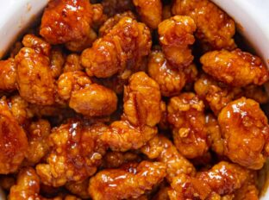
Orange Chicken
Prep time 5 min Cook time 15 min
6 Servings
Ingredients
5 cups chicken nuggets, precooked
2/3 cup barbecue sauce
18 oz sweet orange marmalade
4 tablespoons soy sauce
3 teaspoons sesame oil
Directions
- Prepare rice and chicken nuggets according to package directions.
- Mix ingredients in a microwave safe bowl and cover with a damp paper towel. Microwave for 45 seconds.
- Place nuggets over rice and top with 1/3 to 1/2 cup of sauce.

